Self-Declaration letter on UAN, KYC and PAN-Aadhaar linking

Self-declaration letter is a mandatory document that provides employees' personal details, their KYC linking status with UAN and status of PAN linking with their Aadhaar.

All New hires joining the firm must submit the Self-Declaration letter. Put a tick ‘’ in the check box below (as applicable to your situation):

# For New Hires / Hires without any previous PF/EPS membership):

I certify that the below particulars are true and to the best of my knowledge.

* 1. My name, Father's name, date of birth, and gender is consistent in all three KYC documents (i.e., bank, PAN and Aadhaar).
  2. The Aadhaar, PAN, and bank account details belong to me.
  3. My valid mobile number is linked to my Aadhaar

I authorize Deloitte to use my Aadhaar, PAN and Bank KYCs for verification/ Authentication/ E- KYC/regulatory compliance purposes (as applicable).

I understand that in case of any issues with my KYC or incorrect details provided by me, Deloitte can take disciplinary action against me. I hereby declare and confirm that all the above information provided are valid and true to the best of my knowledge.

Date:

Name:

# For Experienced Hires / Hires with a previous PF/EPS membership):

✅

I certify that the below particulars are true to the best of my knowledge.

* 1. My three KYC details (i.e., Bank, PAN, and Aadhaar) are linked with my existing UAN.
  2. My name, Father's name, date of birth, and gender is consistent in all three KYC documents (i.e., bank, PAN and Aadhaar).
  3. The Aadhaar, PAN, and Bank Account linked to UAN details belong to me.
  4. My valid mobile number is linked to my Aadhaar
  5. I have submitted my E-Nominations on the UAN portal.
  6. I am hereby providing screenshot of my UAN member profile available on the UAN member portal, having personal details, UAN, KYC details (with mapping status) along with E-Nomination completion status

**Steps to take a screenshot from the UAN portal** (Applicable only for experienced Hires)

1. Log in to the [EPFO member portal](https://unifiedportal-mem.epfindia.gov.in/memberinterface/) using your UAN number.
2. Once logged in, you will be able to see the member profile with KYC details (updated/verified/unverified) on the right side of the screen. You must take a screenshot of the homepage and paste the image in the ‘UAN member profile’ box below.
3. Go to ‘Manage’ tab and then choose ‘E-Nomination’. Once you are on the nomination page, take a screenshot and paste the image in the ‘E-nomination’ box below.

I authorize Deloitte to use my Aadhaar for verification/ Authentication/E-KYC purposes for regulatory compliance purposes only. I understand that in case of any issues with my KYC or incorrect details provided by me, Deloitte can take disciplinary action against me.

Below are the supporting screenshots from my UAN member profile and Nomination history.

**UAN Member Profile screenshot**



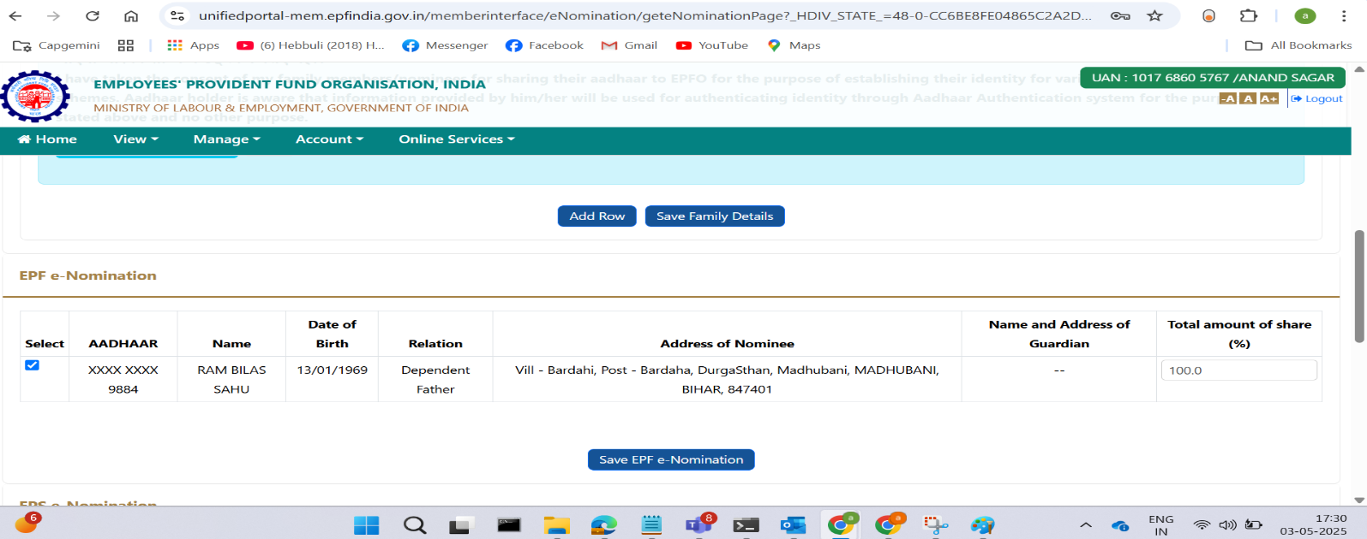

**Steps to check the PAN – Aadhaar linking status** (applicable to all hires)

1. Check the status at this [link.](https://eportal.incometax.gov.in/iec/foservices/%23/pre-login/link-aadhaar-status)
2. Enter your PAN and Aadhaar numbers and click ‘View Link Aadhaar Status.’
3. The PAN-Aadhaar linking status will display on the screen. Take a screenshot and paste the image in the box below.



I hereby declare and confirm that all the above information provided are valid and true to the best of my knowledge

Date : 04/05/2025

Name : Anand Sagar